Computer Networks Lab Report

Submitted By
JAYASAI KOLA
RA2411030050046
Under the guidance of
Dr. Mallika
(Assistant Professor, School of Computing)
in partial fulfilment for the award of the degree
of
BACHELOR OF TECHNOLOGY
in
DEPARTMENT OF COMPUTER SCIENCE AND ENGINEERING WITH CYBER SECURITY
Of
FACULTY OF ENGINEERING AND TECHNOLOGY

SRM INSTITUTE OF SCIENCE AND TECHNOLOGY, TIRUCHIRAPPALLI
Academic Year: 2026–2027

1. Introduction
A LAN lets nearby computers exchange data over a shared medium. In these two experiments a simulator is used to build the smallest useful LAN, first with a switch in the middle and then with a cable running straight between two computers. Each host is given a fixed IP address and ping is used to judge whether the network works.

2. IP Plan and Topology
 | Experiment A | Experiment B
Topology | Star: PC0 - Switch0 - PC1 | Point-to-point, later a star
Network | 192.168.1.0/24 | 192.168.10.0/24
Cable | Straight-Through x 2 | Cross-Over, later Straight-Through x 2
PC0 | 192.168.1.1 | 192.168.10.1
PC1 | 192.168.1.2 | 192.168.10.2
Mask / Gateway | 255.255.255.0 / none | 255.255.255.0 / none

Why no gateway: a default gateway is only consulted when the destination lies outside the sender's subnet. All traffic here stays inside one /24, so the field is left at 0.0.0.0.

3. Key Points to Remember
- A switch sends a frame only out of the port where the destination MAC was learned.
- Unlike devices (PC-switch) use straight-through cables; like devices (PC-PC) use cross-over cables.
- Orange link dot = port still starting; green triangle = port forwarding.
- Ping = ICMP echo request and reply. The TTL value 128 comes from the simulated PC's operating system defaults.
- Simulation mode shows each hop of a packet, while Realtime mode shows only the final result.

4. Experiment A: Two PCs through a Switch
1. Place equipment. Bring two PCs and a switch into Logical view and line them up vertically with the switch in the middle.
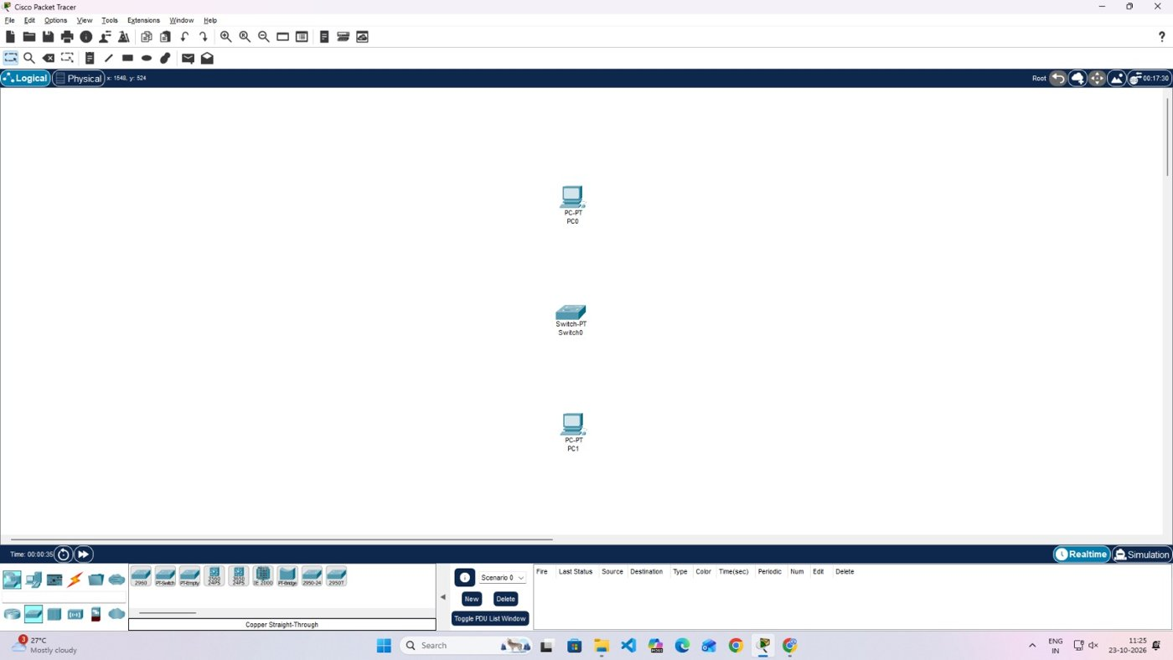
Fig. 1 - Equipment placed on the workspace
2. Choose cable type. Open the Connections palette and select Copper Straight-Through.
3. Connect the hosts. Attach FastEthernet0 of each PC to a free FastEthernet port on the switch. The ports show orange straight away.
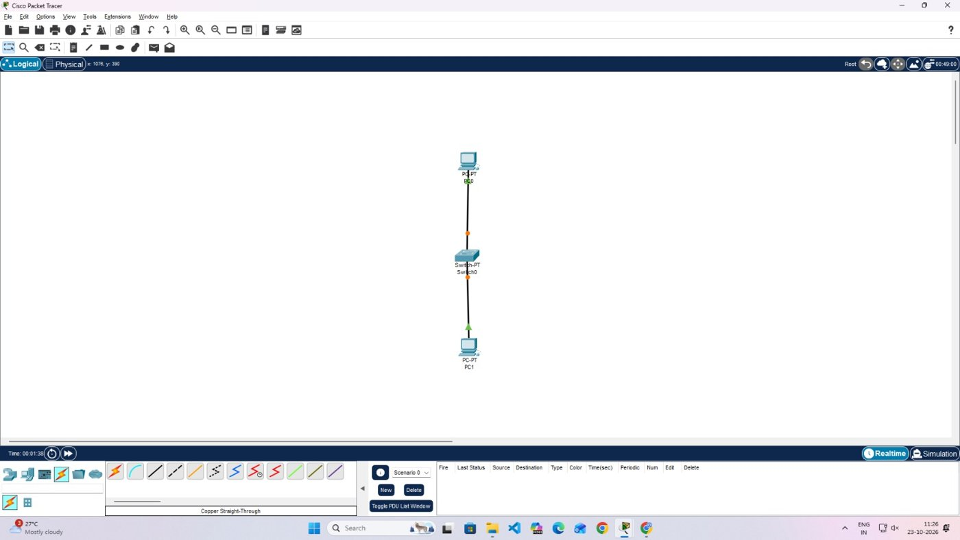
Fig. 2 - Cables attached, ports still orange
4. Check link state. After a short wait every link indicator is green, meaning both ports are up.
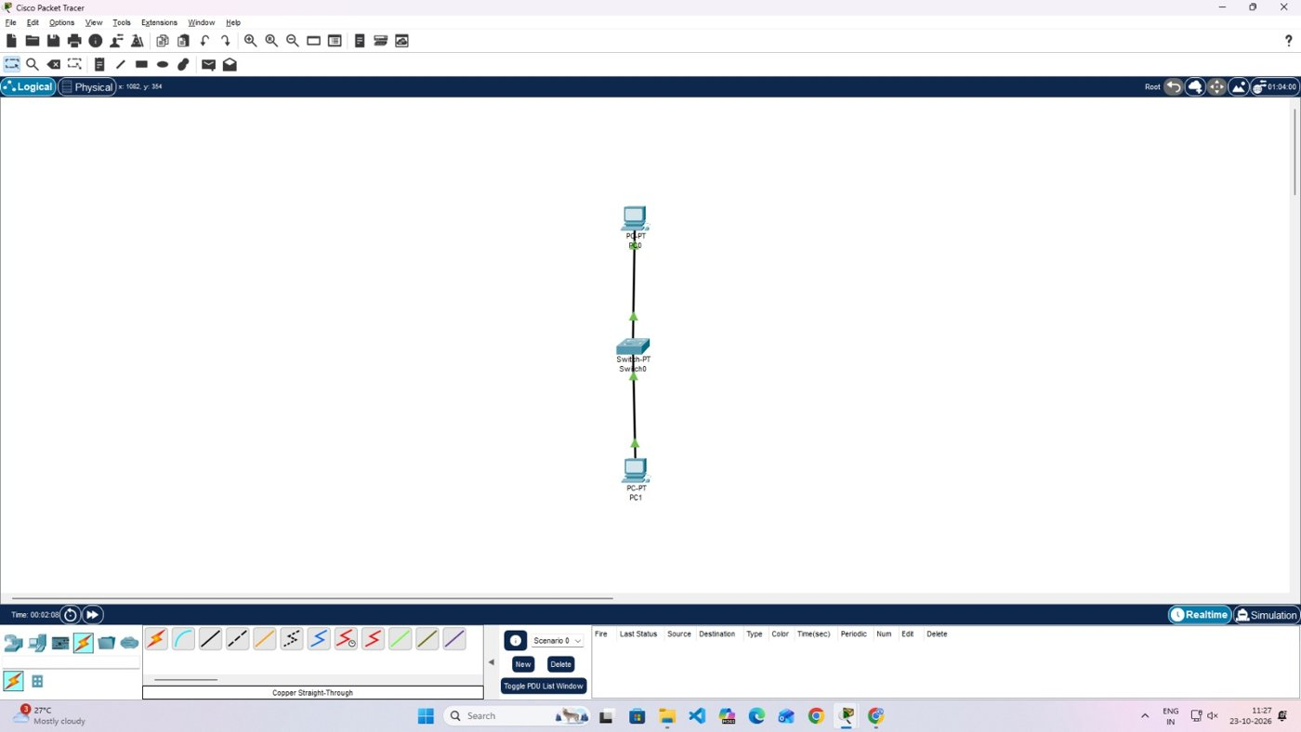
Fig. 3 - All link indicators green
5. Configure PC0. Desktop > IP Configuration > Static: 192.168.1.1 and 255.255.255.0.
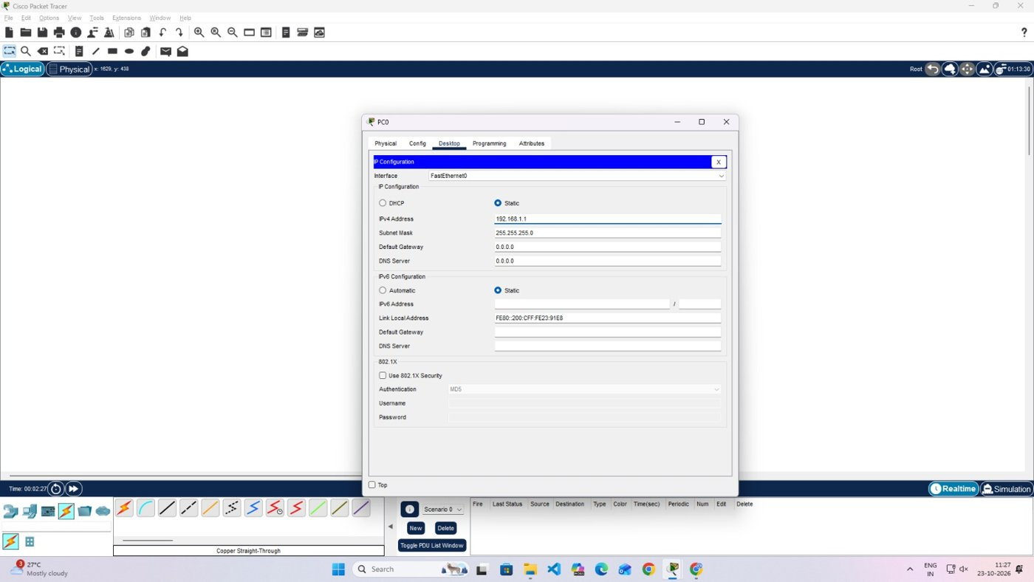
Fig. 4 - Address settings of PC0
6. Configure PC1. Same screen on PC1: 192.168.1.2 and 255.255.255.0.
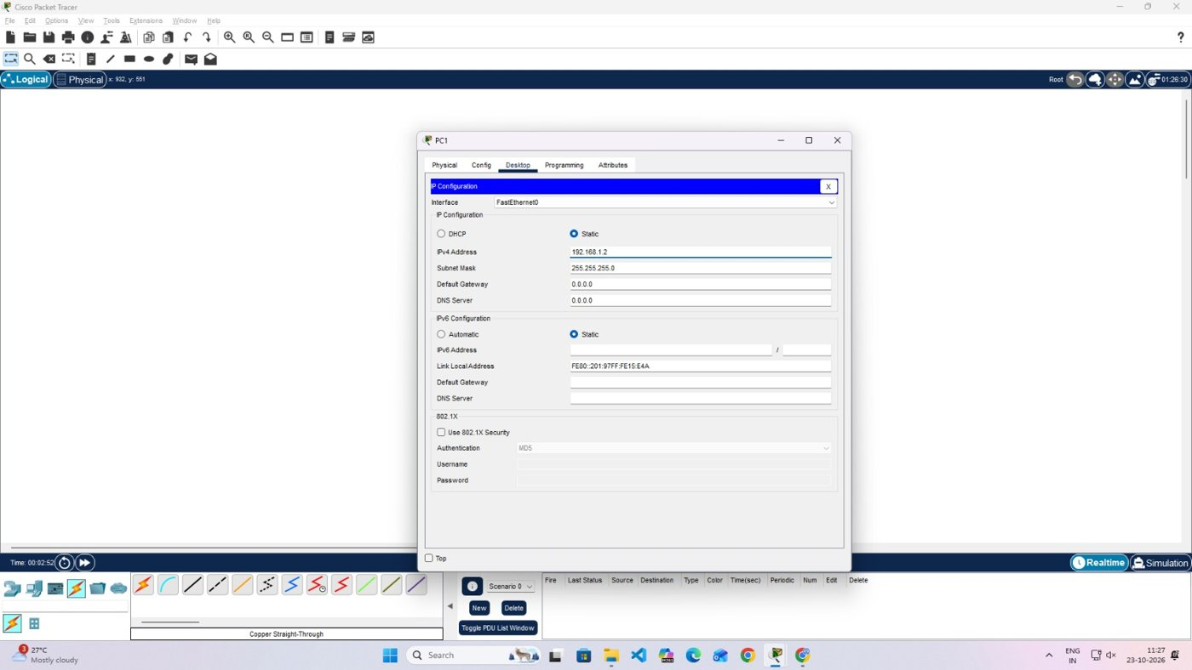
Fig. 5 - Address settings of PC1
7. Ping PC0 from PC1. In the Command Prompt of PC1 type ping 192.168.1.1.
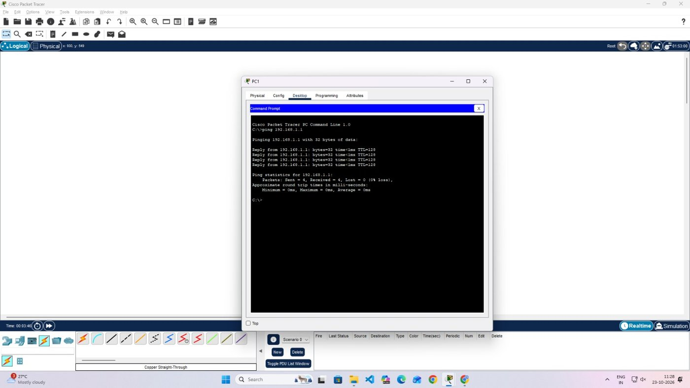
Fig. 6 - Four replies received on PC1
8. Ping PC1 from PC0. In the Command Prompt of PC0 type ping 192.168.1.2.
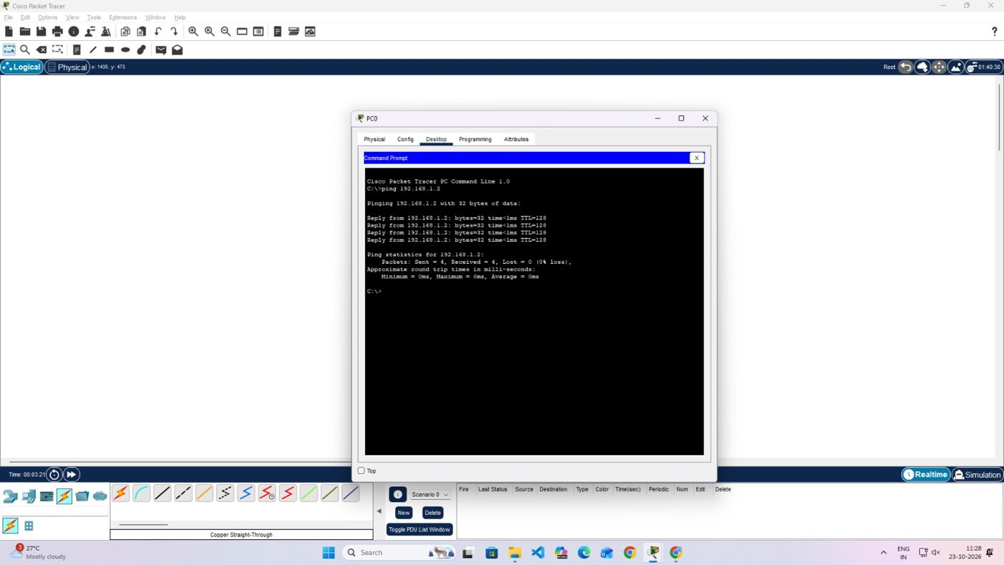
Fig. 7 - Four replies received on PC0
9. Trace a packet. Switch to Simulation mode, create a PDU and play the events. The envelope goes from the PC to the switch and then to the other PC.
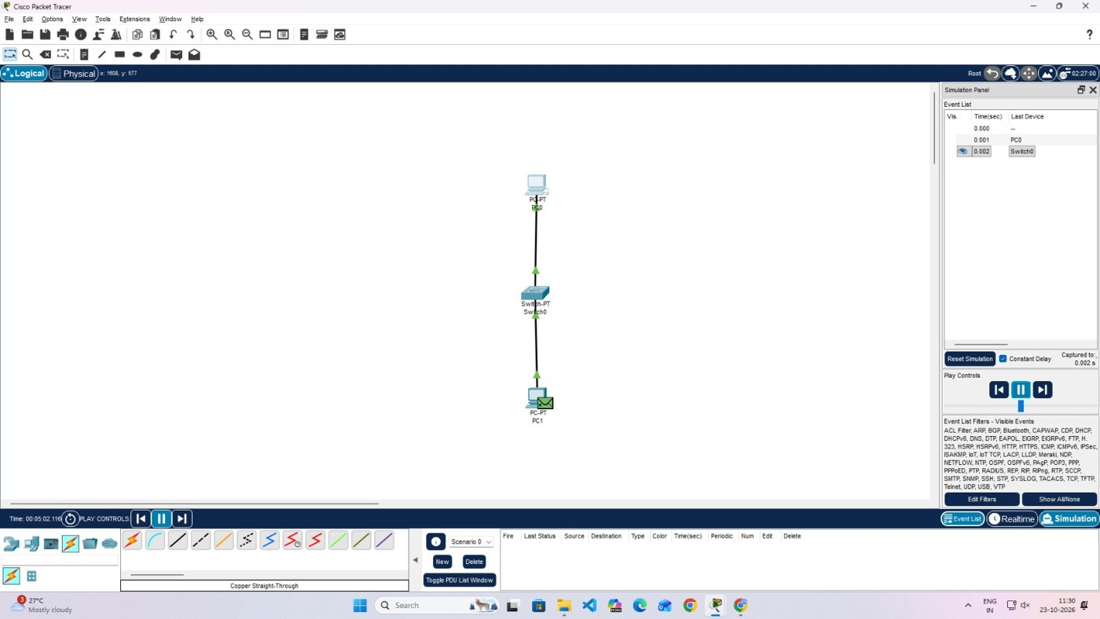
Fig. 8 - Packet captured in Simulation mode
Result of Experiment A: 4 packets sent, 4 received, none lost; times under 1 ms; TTL 128.

5. Experiment B: Cross-Over Link, then Switch
1. Place two PCs. Open an empty workspace and add PC0 and PC1.
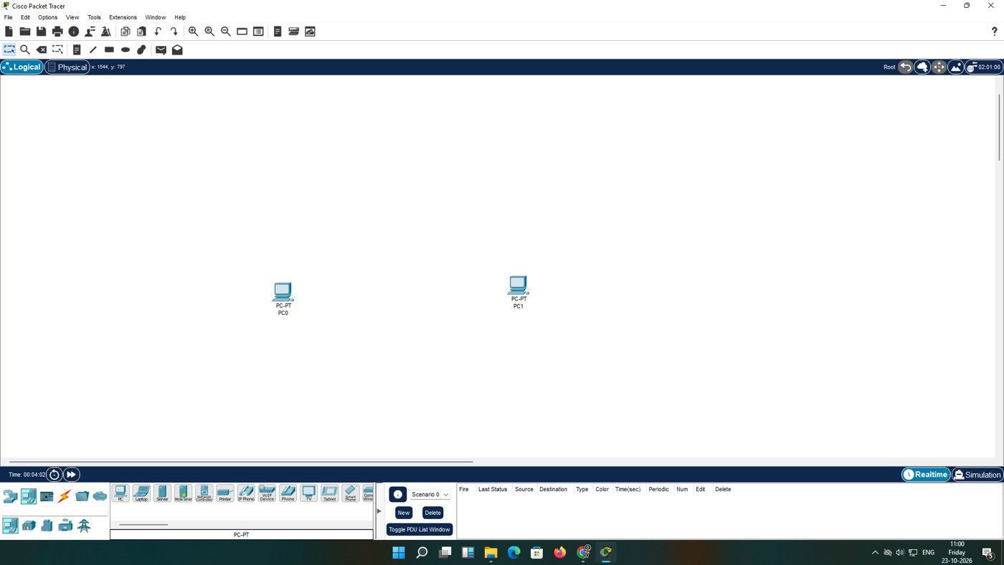
Fig. 9 - Two PCs on a blank workspace
2. Use a cross-over cable. PC-to-PC is a like-to-like connection, so choose Copper Cross-Over.
3. Pick the Ethernet port. Click PC0 and select FastEthernet0 in the pop-up list; RS 232 and the USB entries are not Ethernet.
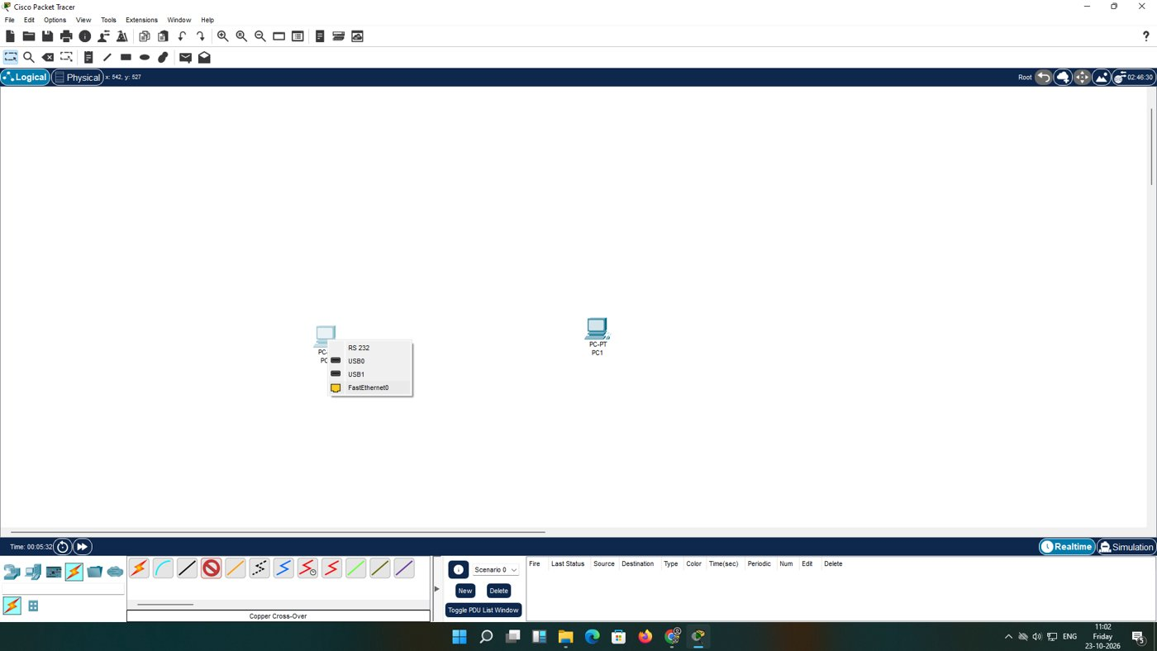
Fig. 10 - Port menu on PC0
4. Connect PC1. Click PC1 and select FastEthernet0. A dashed line with green triangles means the link is active.
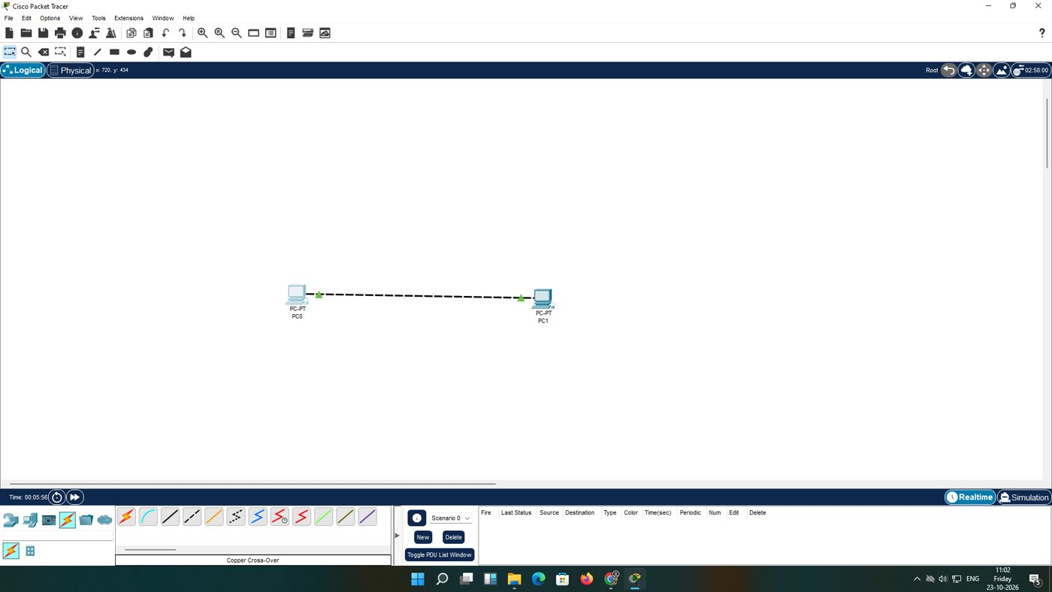
Fig. 11 - Cross-over cable connected
5. Address PC0. 192.168.10.1 with mask 255.255.255.0.
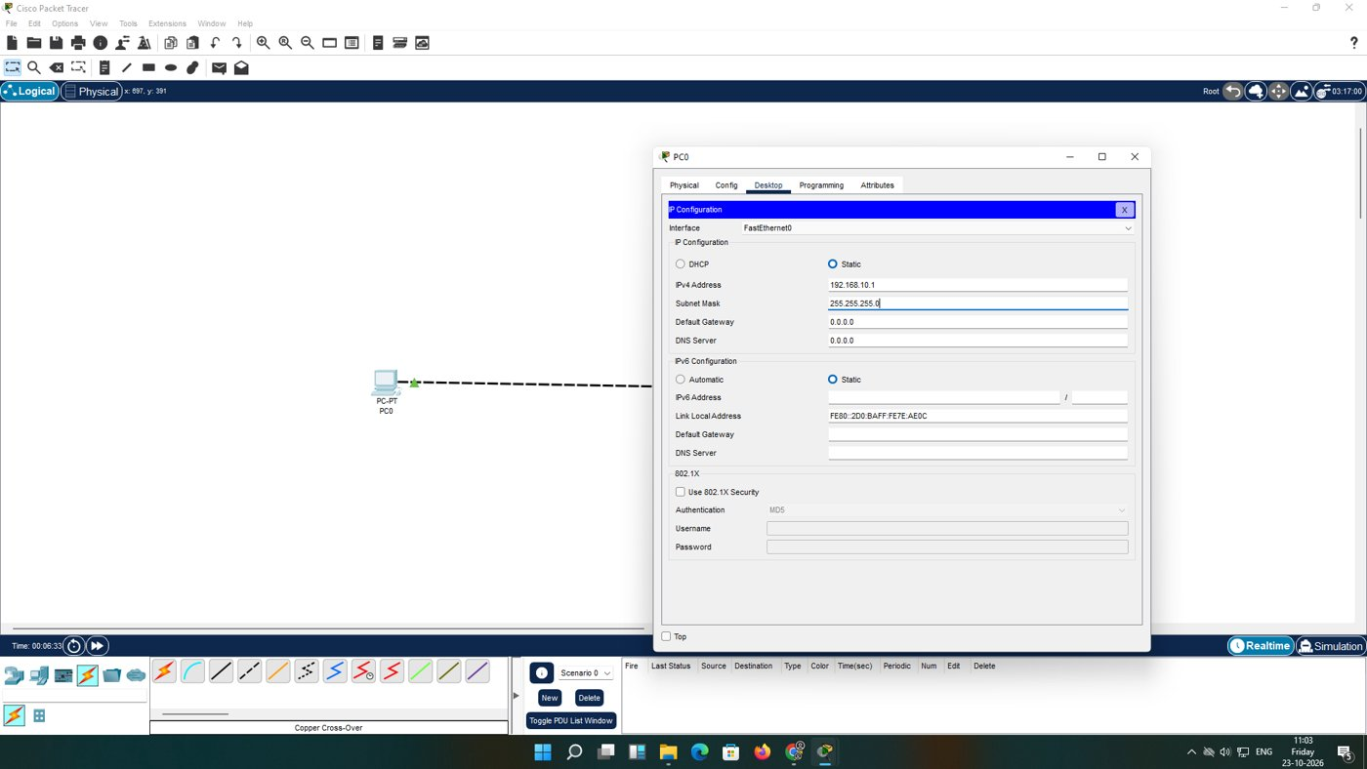
Fig. 12 - Settings of PC0
6. Address PC1. 192.168.10.2 with mask 255.255.255.0.
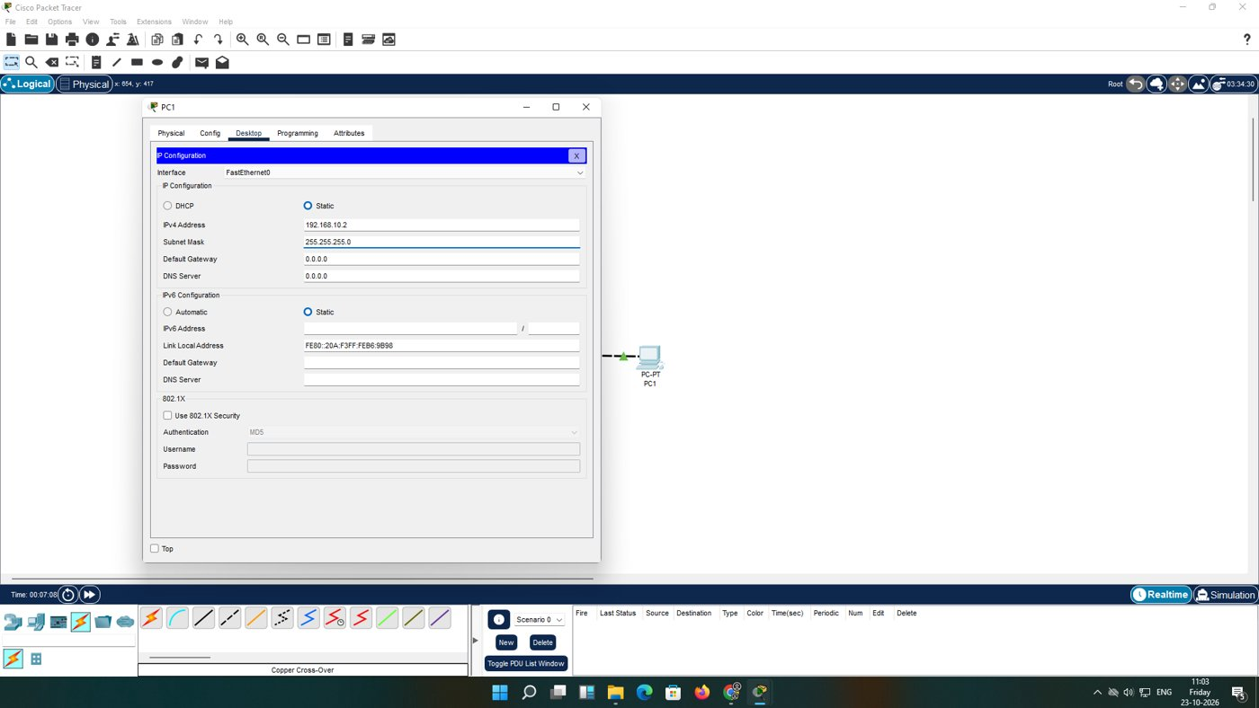
Fig. 13 - Settings of PC1
7. Test the direct link. From PC0 run ping 192.168.10.2; all replies come back in under 1 ms.
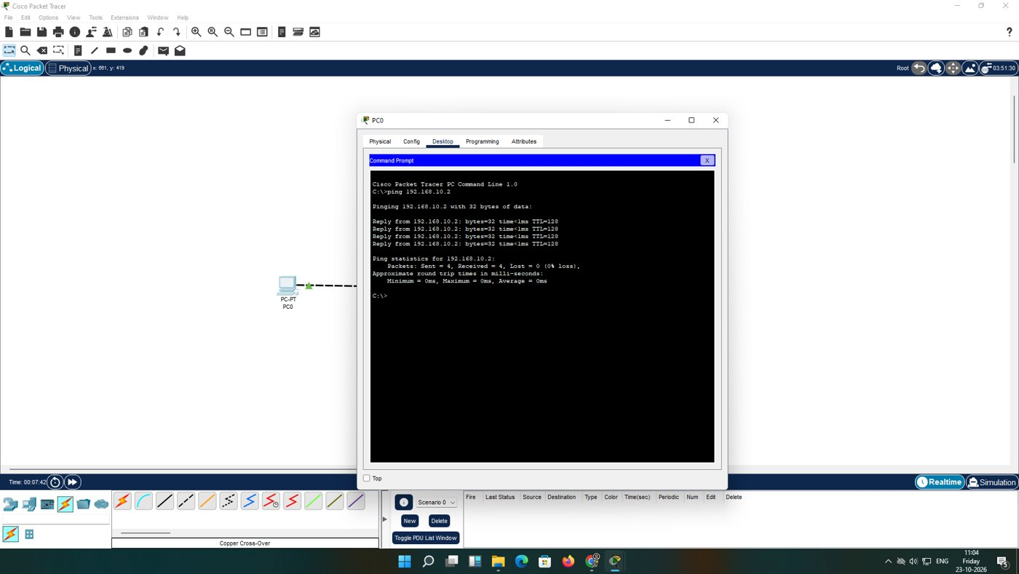
Fig. 14 - Ping across the cross-over cable
8. Introduce a switch. Add a 2960-24TT from the Switches list.
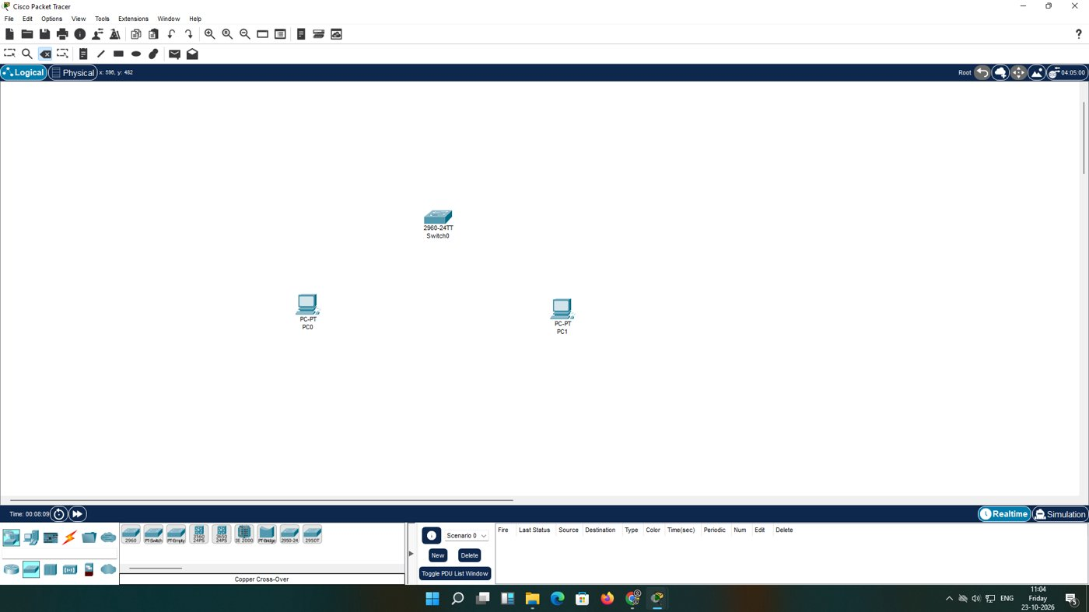
Fig. 15 - Switch0 placed
9. Rewire. Delete the cross-over cable and connect each PC to Switch0 using straight-through cables. The ports go orange, then green.
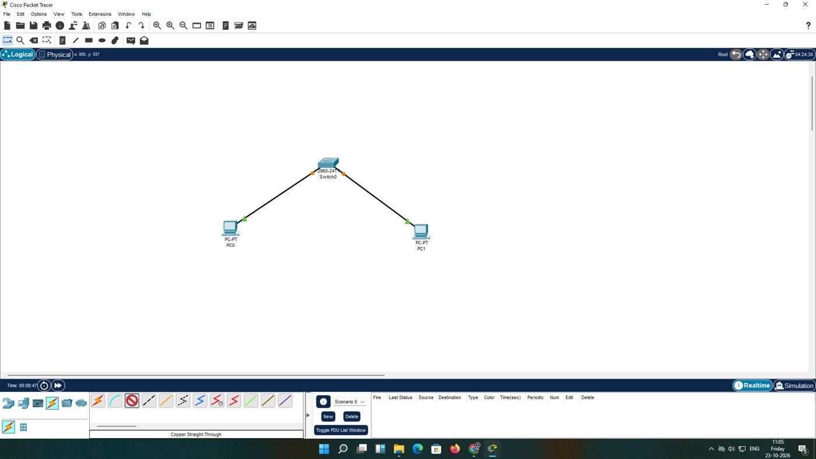
Fig. 16 - Both PCs attached to Switch0
10. Test again. From PC1 run ping 192.168.10.1. The first reply is slower (6 ms) while ARP and MAC learning finish.
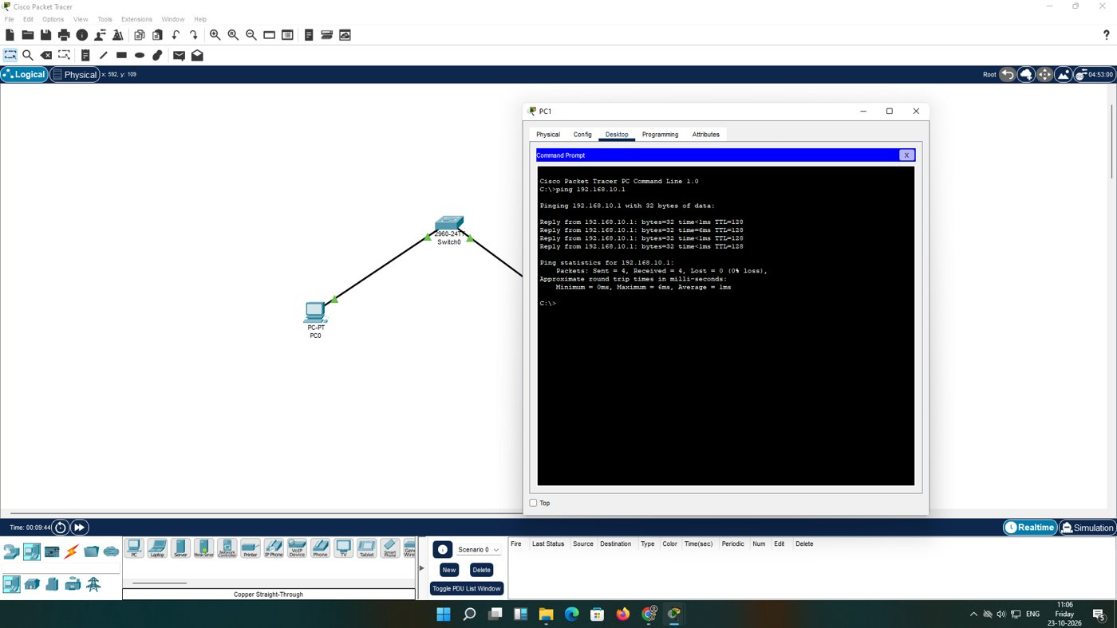
Fig. 17 - Ping through the switch
Result of Experiment B: 0% loss in both tests. Through the switch the times were min 0 ms, max 6 ms, average 1 ms.

6. Verification Summary
Test | From | To | Sent / Received | Outcome
A-1 | PC1 | 192.168.1.1 | 4 / 4 | 0% loss, <1 ms
A-2 | PC0 | 192.168.1.2 | 4 / 4 | 0% loss, <1 ms
B-1 (cross-over) | PC0 | 192.168.10.2 | 4 / 4 | 0% loss, <1 ms
B-2 (switch) | PC1 | 192.168.10.1 | 4 / 4 | 0% loss, avg 1 ms

7. What I Learned
- The cable type must match the pair of devices being joined.
- Hosts in one subnet need no gateway.
- A switch learns MAC addresses, so the first packet can be a little slower.
- Simulation mode lets us see where a packet is at each moment.

8. Conclusion
Both experiments produced working LANs with no packet loss. The switch design is the one that can grow, while the cross-over cable suits a quick link between exactly two machines.

